DEBIAN 64bits – INSTRUCTION MANUAL!

- Let’s Install the Operating System on Virtual Machine

First install in your operating system “Oracle Virtual Bow” in this link https://www.virtualbox.org/ in download section.
After installing, launch this application.
Click on the “New” for creating new Virtual Machine:
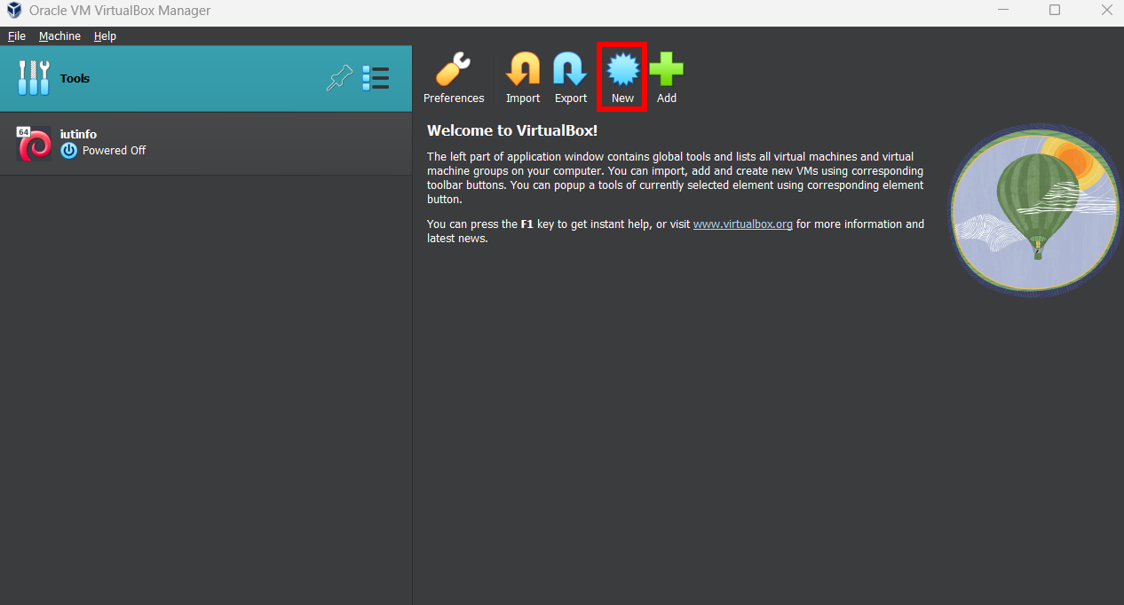
Enter the name of Virtual Machine, it’s your choice.
Select the type for “Linux” and Version section select “Debian 64 bits”.
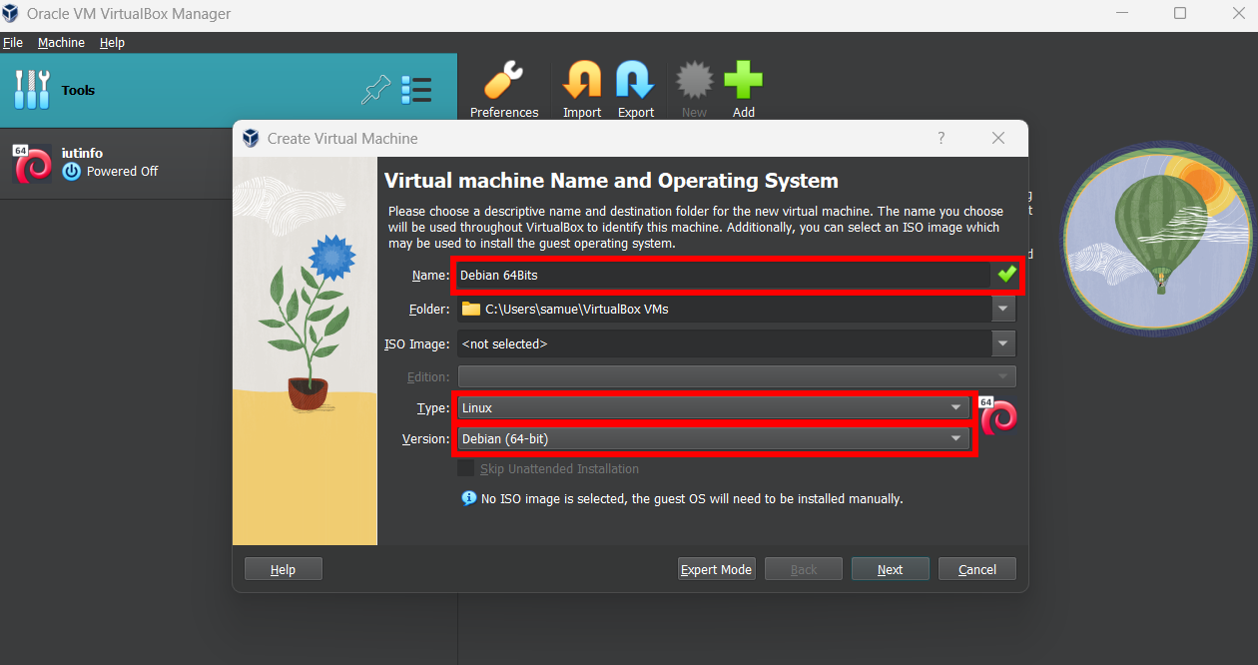

Click on “next” for continue…
Default Settings add “2048 MB of base memory and 1 CPU” … change for your usage.
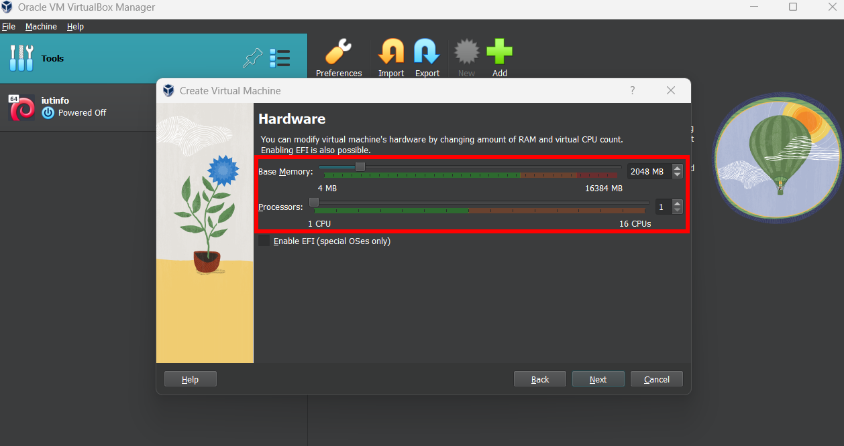
Click on “next” for continue…
By default, the setting in set on “create a virtual hard disk” and 20 GB selecting … change for your usage.
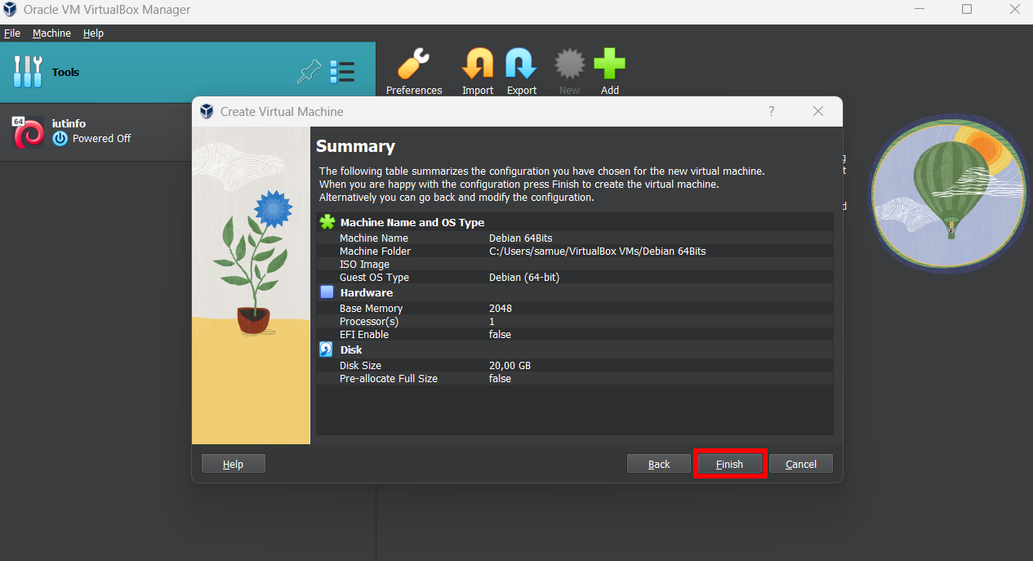
Click on “finish” for continue…

- Insert the virtual bootable disc!

First Click on your virtual machine:
Click on Settings…
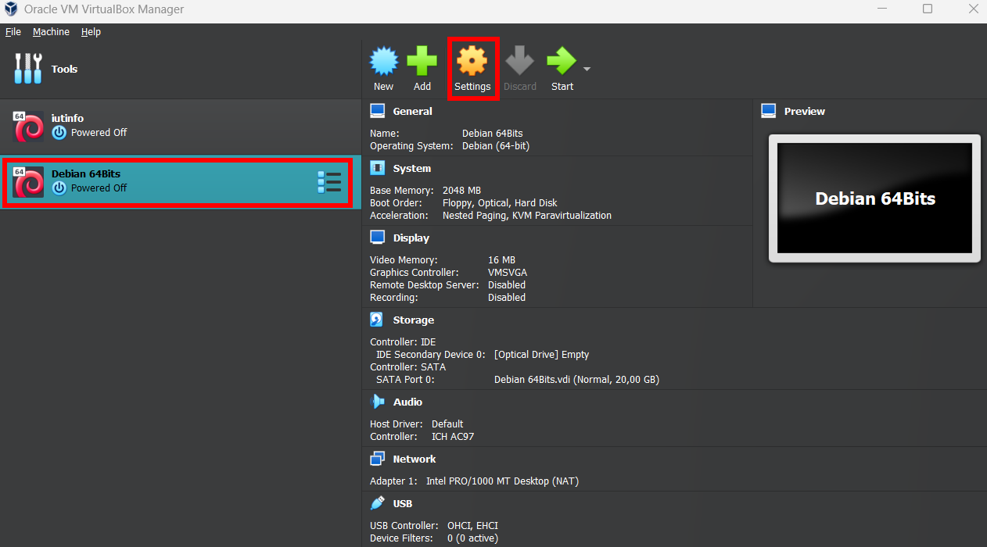
Click on Storage Section…
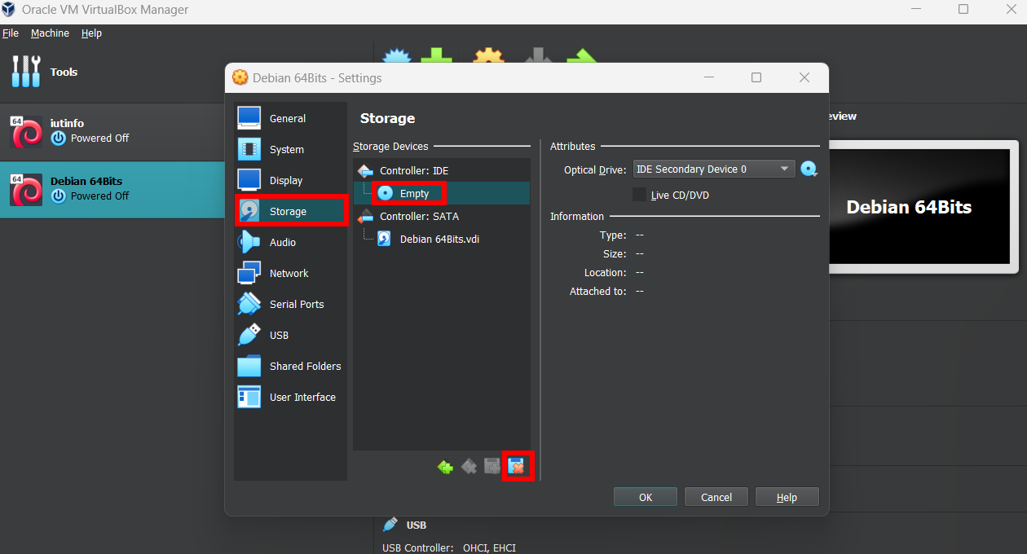

Click on the empty disc… and delete this…
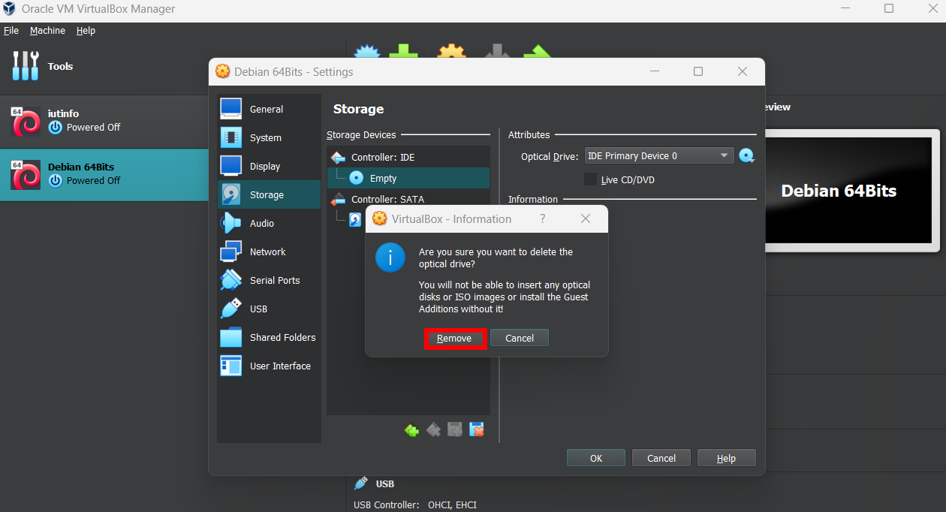
Click on remove…
Click on “Add Attachment” and select optical drive…
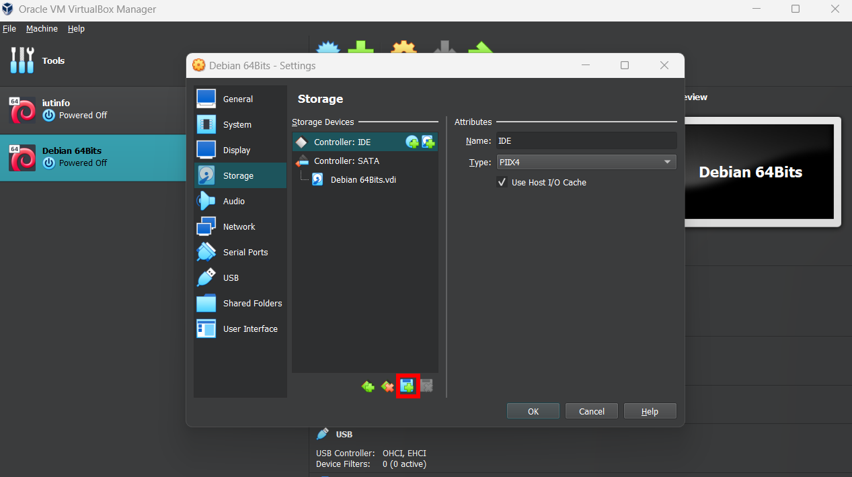

Click on “add” … and select your linux installation (.iso) in /home/virtual-machine/___.iso.
By default, is named “mini-12-bookworm-amd64.iso”.
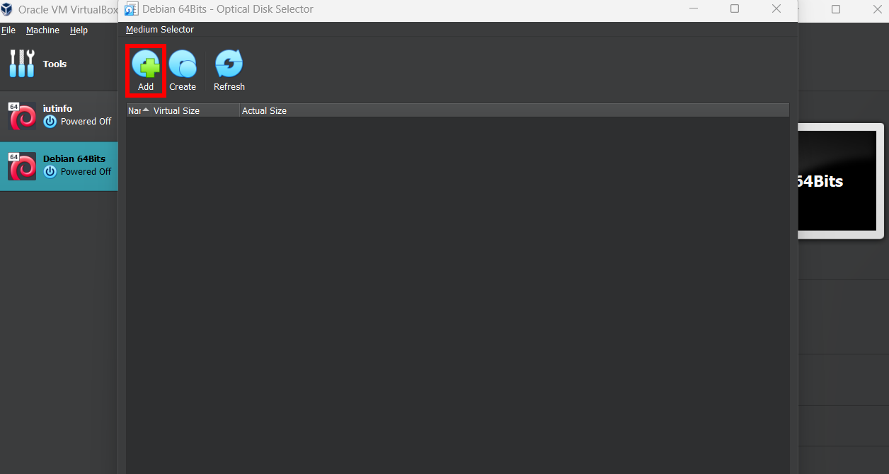
Click on choose…
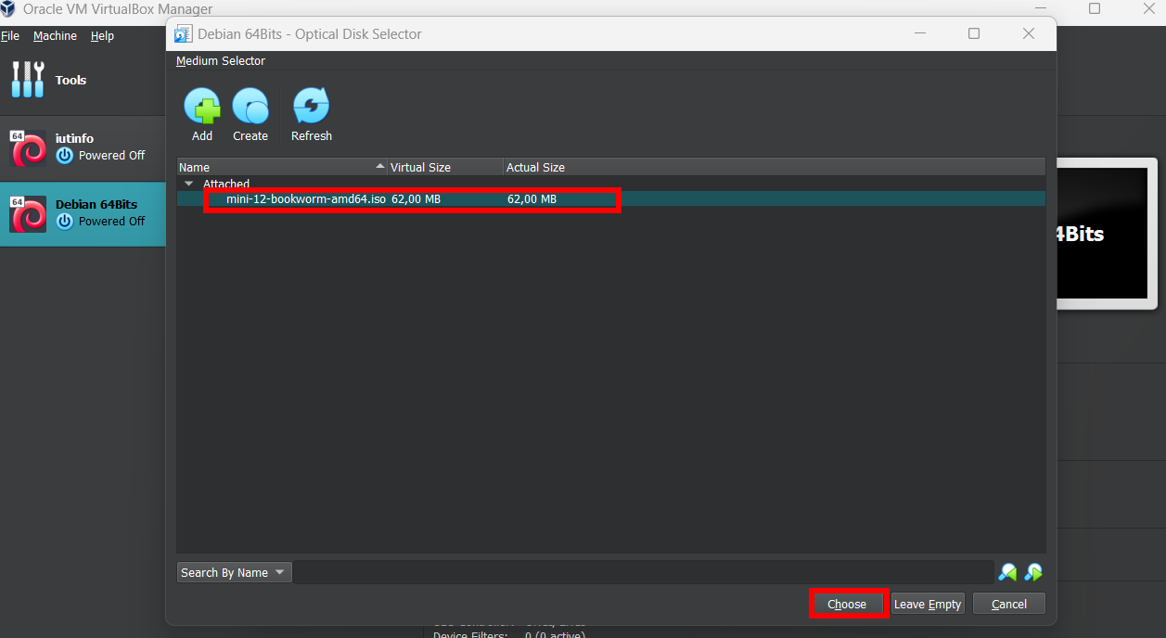
And Ok…

Launch for testing… it’s working… done!
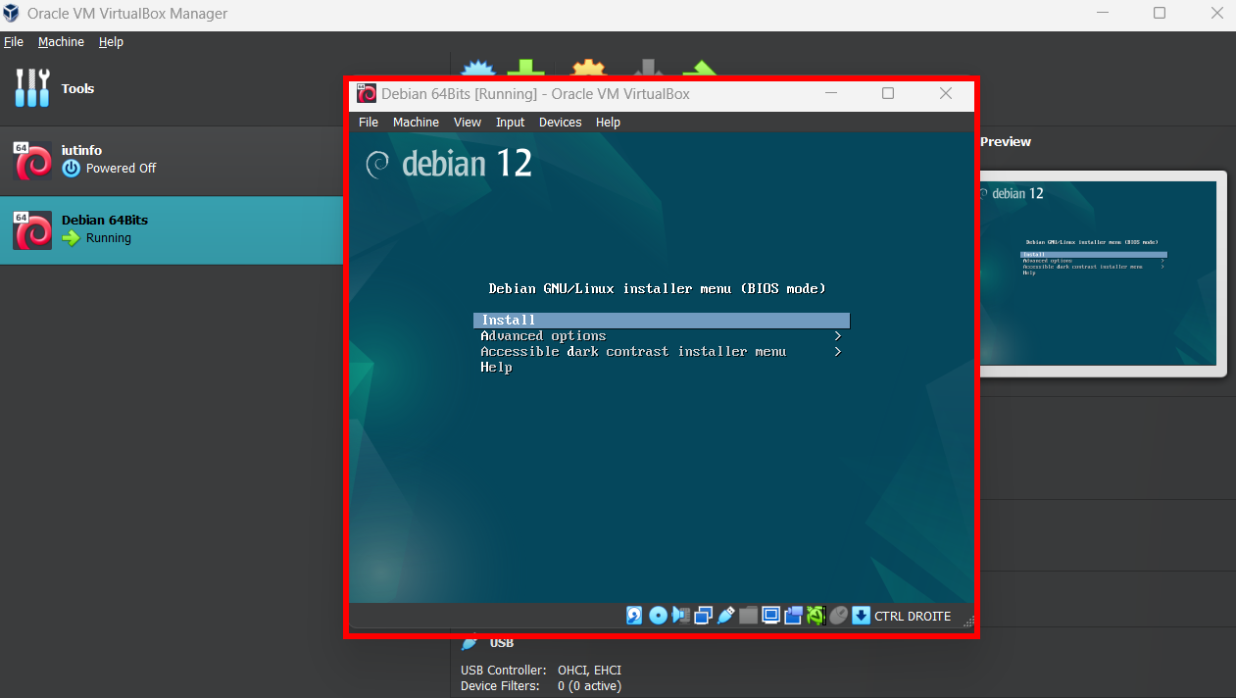

- Installing the OS

After launching the virtual machine select Install and push enter button.
In this hub you can’t use the mouse… only “enter” and directional arrows…
Optimal Settings:

Language: Select your language.
Country: Select your country.
Keymap: It’s important for the disposition of keyboard (QWERTY and AZERTY), select your country.
Hostname: the default is good…
Domain name: enter a name…
Debian archive mirror country: Select your country.
Debian archive mirror: deb.debian.org
HTTP proxy: empty
Root password: It’s the password of the ultimate chief of your computer (power of delete all operating system), make password stronger and confirm.
Full name of the user: Enter your name or pseudonym… and select same for account.
Password for the user: Make a password for you…
Select Time Zone: Your time zone…
Partitioning method: Select default, guided – use entire disk… and select your disk… all file in one partition…
View your settings and click on finish… and yes.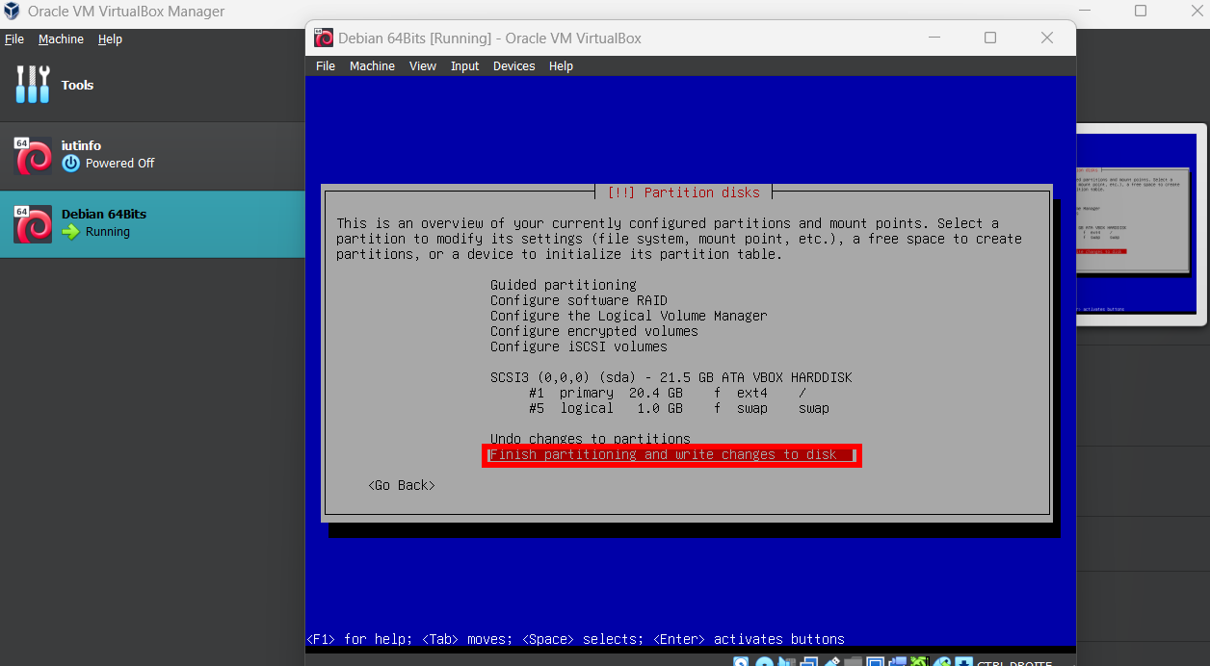
Leave the default settings…
Select the second option…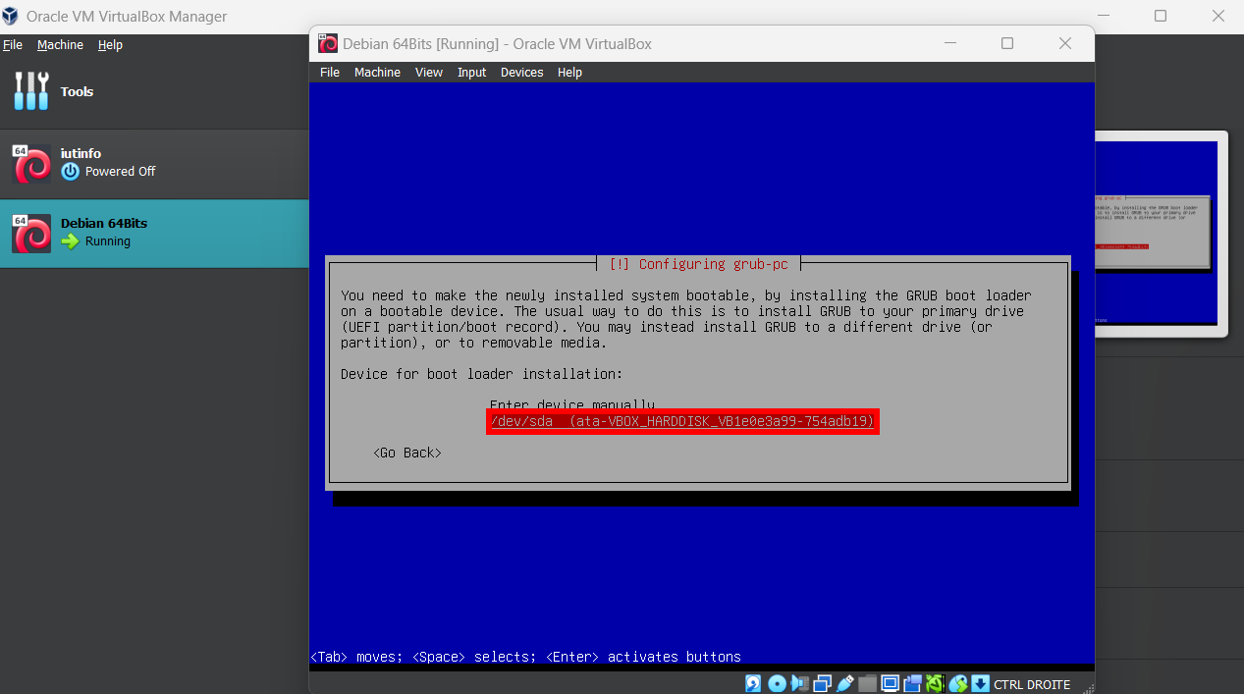

DO NOT REBOOT OTHERWISE YOU’LL HAVE TO RETRY ALL INSTALLATION!
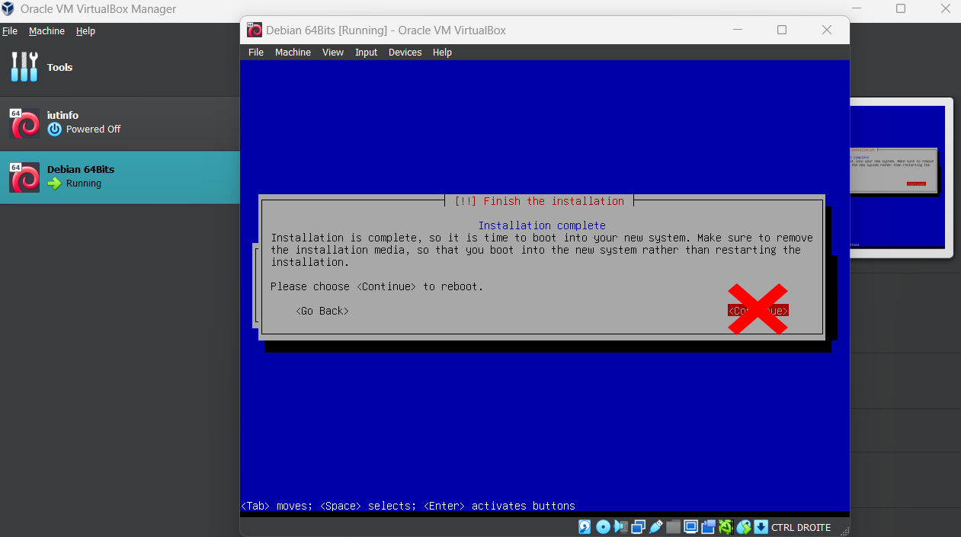
… Power Off the system
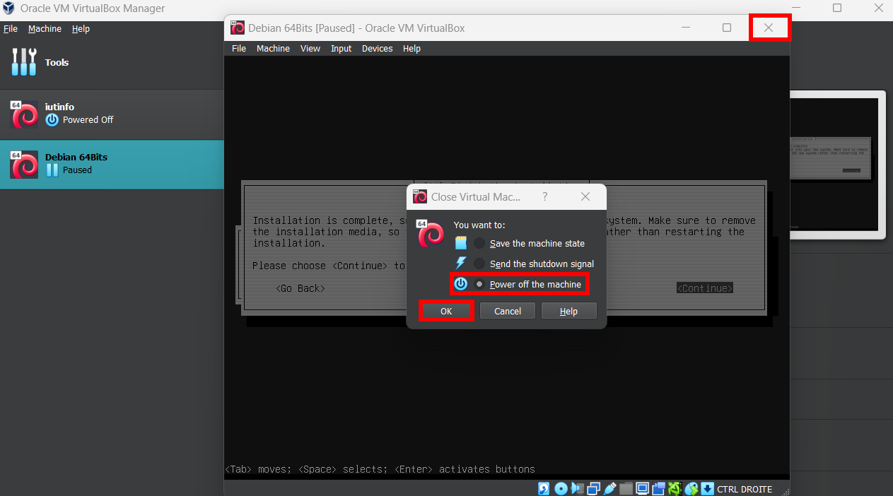
In setting select in the storage section the disc ___.iso and delete this… and start your virtual machine for the change…

It’s done. Enter your username and password and it’s worked!!!

- How to install application

For installing application in Debian, the user must open the Terminal with keyboard conbinaison (Ctrl + Alt +T).
Open another window with Firefox is deliver on base version of Debian.
Research with Firefox the application that you want install (example: Visual Studio Code)
In official website of application click in the download section and Linux section download the component…
cd ../Downloads
And follow the tutorial of installation…

- Add User and Groups Users

For add a user open the terminal and execute “su” to change your right for root…
Enter the root password.
Enter the command: sudo adduser name_of_user on replace name_of_user by the name of new user…
For create a group it’s require same instruction with root… and enter this command: sudo groupadd name_of_group user_name on replace name_of_group by the name of groups and user_name by the user choice to add in group…

For more information and helping visit the official Debian wiki: https://wiki.debian.org/

551 mots

